Development of Phonological Awareness

Young children’s developing phonological awareness is characterized by a progressively more refined awareness of shorter and more abstract segments of speech (Wagner.

Continuum of Complexity of Phonological Awareness Activities
(Schuele & Boudreau, 2008, LSHSS)
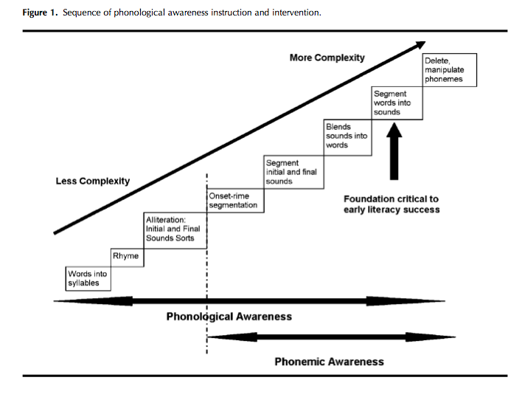

PRESCHOOL YEARS

In the preschool years, children may begin to acquire some phonological awareness. This awareness is likely to be inconsistent or fleeting and reflect simple, shallow abilities.

This awareness can emerge from a child’s participation in daily experiences that focus the child’s attention on the structure of language (rather than on the meaning of language).

Maddie, a three-year-old, seems very interested in letters and sounds. She has a toy school bus that says the names and sounds of letters when she presses the buttons. She said to her mom, “fffffireplace. That starts with fffff. The letter F.” Maddie’s comments about letters and sounds likely cause her mom to tell her more about letters and sounds.

Chip, who just turned four, likes his mom to read Dr. Suess books to him. He seems to love the rhymes – if his mom pauses when she reads, Chip fills in the rhyme word. Chip’s mom noticed yesterday in the car that Chip was repeating the rhyme words from the books and adding new rhyming words.

Increasingly, children participate in emergent literacy experiences in their preschool classrooms that focus their attention on the sounds of language and support the development of phonological awareness. For preschool children, literacy experiences embedded in everyday events and routines (e.g., reading books, playing house, playing rhyme games) are thought to be preferable to specific, structured didactic instruction (e.g., drill, worksheets).

REMEMBER

Preschool children have varying levels of knowledge and experience with the sounds of language, print, books, and so on. Thus, they come to kindergarten with very different abilities. At one extreme, some children are already reading; at the other extreme, some children cannot match rhyming words or say the first sound of their names. Kindergarten curricula and instruction must meet the needs of all children.

KINDERGARTEN

ABCDEFGHIJKLMNOPQRSTUVWXYZABCDEFGHIJKLMNOPQRSTUVWXYZABCDEFGHIJKLMNOPQRSTUV

Although kindergarten used to be a place to play and socialize, kindergarten classrooms today look a lot more like first grade classrooms of years gone by. Kindergarten children are engaged in explicit literacy activities. What are they expected to learn? Letters names. Letters sounds. Segment sounds. Match sounds. Spell simple words. Read simple words. Write simple words.

Twenty years ago, kindergarten children may not have participated in many explicit literacy activities. If they did, these activities below might have been used to promote phonological awareness:
RHYME: match rhyming words and generate rhyming words
LETTERS AND SOUNDS: learn the sound for each alphabet letter
BEGINNING SOUNDS: identify pictures that begin with a certain sound and letter

Today’s kindergarten literacy curricula expect more of children. Children need to learn more advanced phonological awareness skills to succeed. They need to acquire deeper phonological awareness skills, that is, phonemic awareness. In addition to the skills listed above, kindergarten children now are often expected to learn:
SEGMENT SOUNDS: segment a word into all its sounds
MATCH SOUNDS: match words based on consonant sounds and vowel sounds

FIRST GRADE AND BEYOND

In first grade, children have lots of opportunities to use their phonological awareness as they learn to read and write: decoding words and spelling words. If children developed a foundation of phonological awareness in kindergarten, reading and writing instruction will further develop children’s phonological awareness, particularly explicit awareness at the phonemic level. Children will become increasingly capable at blending sounds to form words and at segmenting words into sounds in order to spell those words. Learning to read asserts an influence on the development of more complex phonological awareness skills. The development of phonological awareness can continue to develop throughout one's life (e.g., humor based on sounds of words, foreign language learning, poetry, secret language such as Pig Latin, phonetics courses in college).

If children come to first grade without a foundation of phonological awareness, they will likely have difficulties learning to decode words and learning to write words. The first grade curricula must provide not only decoding and spelling instruction, but instruction that ensures that children have an opportunity to develop a foundation of phonological awareness. Children in first grade need to be able to blend sounds into words AND segment words into sounds. Words should include simple consonant-vowel-consonant words, like cat, ship, bike (all three sounds) and words with consonant blends, like plum, jump, skip (all four sounds, with a blend).

What should children know when?

Torgesen and Mathes (2000) proposed this framework for what children should now. However, the expectations seem somewhat to underestimate curricular expectations in most school districts.

LEARNING: Benchmarks

To think about what children should be able to do at what age, it is essential to examine the curricular expectations for achievement. An examination of kindergarten and first grade curricula, leads to the proposed benchmarks below. Teachers should expect children to show development of these skills (i.e., inconsistent performance, performance that needs to be supported by adult help) long before mastery. Ultimately, children must develop skill in segmenting and blending. Earlier developing skills are targeted as a means to facilitate later developing skills (i.e., segmentation, blending). It may be useful to think of three abilities levels that children demonstrate alongside thinking about the skills children are learning.
EMERGING ABILITY: Children are occasionally successful on a skill, but usually not successful. That is, a child is not often successful when attempting to display the skill independently (without adult support). In highly supportive, scaffolded interactions with adults, children show increasingly ability.
DEVELOPING: Children are sometimes independently successful in displaying a skill. With scaffolding and support, children are very often successful. The amount or level of scaffolding children need to be successful is decreased as instruction proceeds. Children are independently successful more often. Children are most challenged by complex or difficult instances of displaying the skill. Their lack of skill is typically not attributable to lack of motivation or lack of attention to the task.
MASTERY: Children are independently successful most of the time. Their failures can often be attributed to performance factors, such as not paying attention or lack of motivation. They fail occasionally, typically in more complex or difficult instances of displaying the skill.

AGE | SKILL OR ABILITY
preschool | segment words into syllables (or sentences into words but only with all monosyllabic words)  some rhyming ability  some beginning sound ability
early kindergarten | judge rhyming words  generate rhyming words
middle kindergarten | match words with same beginning sounds  match words with same final sounds  segment initial sounds and final sounds
late kindergarten | segment in two and three sound words that are consonant-vowel (e.g., go) , vowel-consonant (e.g., up), consonant-vowel- consonant (e.g., cat, moon)  match words with same vowels
early first grade | segment sounds in words with blends (e.g., skate, jump)

By the time formal reading instruction begins, children should have:
A foundation of phonological awareness is necessary for children to succeed in early literacy instruction.

How much phonological awareness is enough to get started?
- a threshold level of phonological awareness that enables the child to benefit from reading instruction in the classroom (i.e., the regular reading curricula)
- basic understanding that language is composed of words and words of sounds segment CV, VC, and CVC words consistently and show some ability to segment words with consonant blends (CCVC, CVCC) (C=consonant, V=vowel)

