Five Little Snowflakes

One little snowflake with nothing to do.
Along came another, and then there were two.

Two little snowflakes laughing with me.
Along came another, and then there were three.

Three little snowflakes looking for some more.
Along came another, and then there were four.

Four little snowflakes dancing a jive.
Along came another and then there were five.

Five little snowflakes having so much fun.
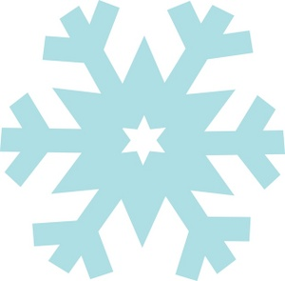
Out came the sun, and then there were none!
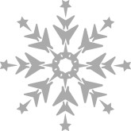

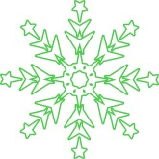

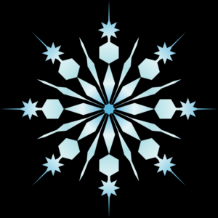
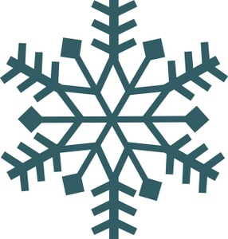

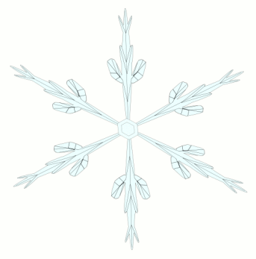
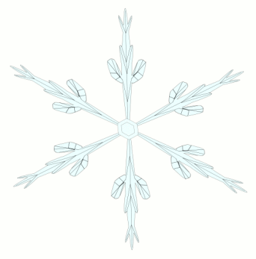
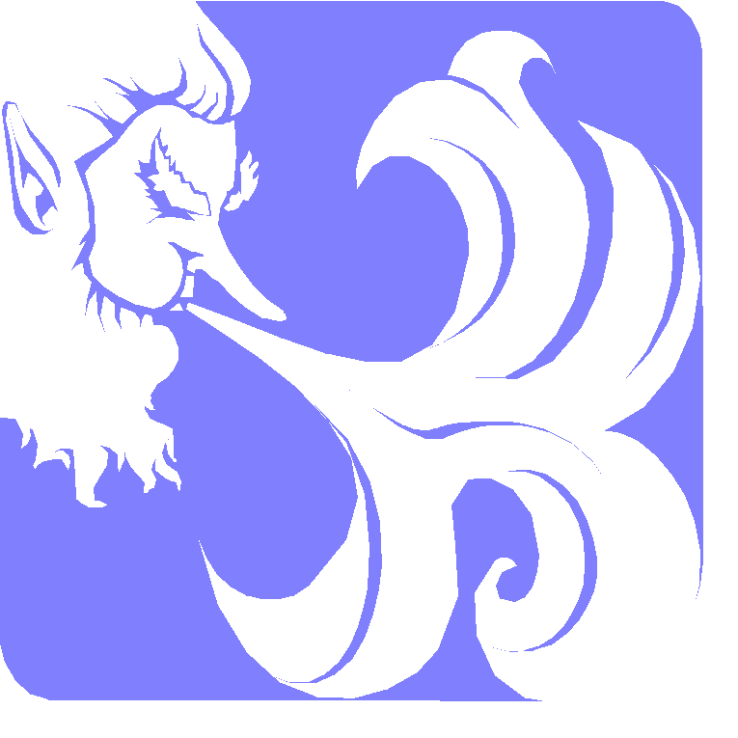

I Do Not Mind You, Winter Wind

I do not mind you, Winter Wind,
When you come whirling by,
To tickle me with snowflakes
Drifting softly from the sky.

I do not even mind you
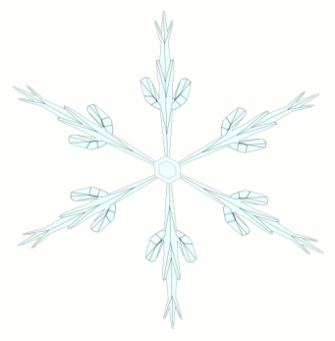
When you nibble at my skin,
Scrambling over all of me
Attempting to get in.

But when you bowl me over
And I land on my behind,
Then I must tell you, Winter Wind,
I mind! I really mind!

Jack Prelutsky

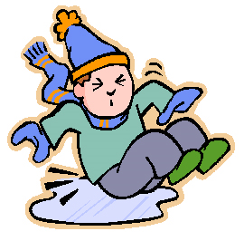

Snow-Lady
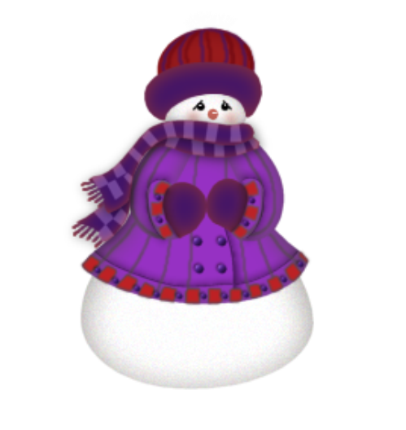
Snow-lady, snow-lady,
Out there in the cold,
With your fat carrot-nose,
And your buttons of gold.

The hat on your head,
Has a snow-ribbon band,
And a robin has perched,
On your ice-stiffened hand.

Snow-lady, snow-lady,
Please don’t go away!
We’ll build a tall snowman
Beside you today.

Then you won’t feel lonely,
Out there in the night,
With the moon shining down,
And the frosty sunlight.

Mary Jeffries

Polar Bowling

It used to be that polar bears
Went bowling, just for grins,
With snowballs for their bowling balls,
And penguins as the pins.

The bears would have a blast,
With all the snowballs that they threw.
The penguins weren’t as happy;
That’s the only time they flew.

So penguins all moved south and now,
They’re at the other pole.
Well, wouldn’t you move far away
If bears used you to bowl?
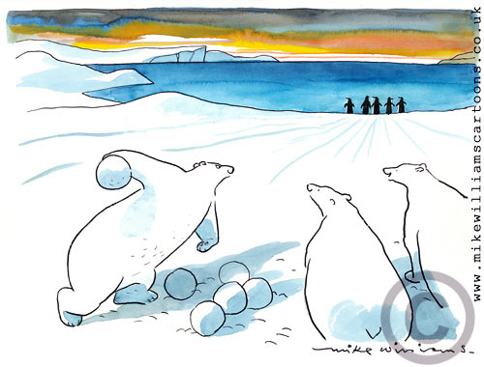

Kenn Nesbitt

Melinda Made A Snowman

Melinda made a snowman,
Which she gave a carrot nose.
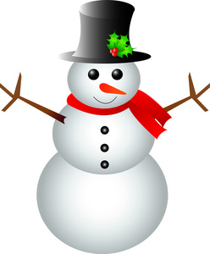
She placed some rubber boots,
On what she figured were his toes.

Melinda gave him charcoal eyes,
And after one last pat,
Upon her snowman’s frozen head,
She placed her father’s hat.

She thought him nearly finished,
And then as a final note,
She took her father’s favorite tie,
And draped it ‘round his throat.

Melinda was so proud of him,
She rushed upstairs with glee.
She hollered to her mom and dad
To “Hurry! Come and see!”

But by the time they came downstairs,
Melinda cried and cried.
“Melinda,” Mom and Dad said,
“snowmen must be made outside.”

Linda Knaus

Bundled Up

I’ve got my turtleneck and sweater
And my thickest socks and pants,
My jacket and my hat and scarf
And mittens for my hands.

Button. Zipper. Snap.
I’m snugly fastened in.
But I think I’ll need a day or two
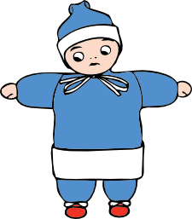
To get back out again.

Arden Dickenson

