Bilingual Speech and Language Services
Interpreter Informational Sheet
You are required to:
- Read and adhere to Processes and Procedures for Interpreters (below)
- Communicate with Service Provider prior to testing/meeting to discuss requirement needs
- Attend assessment session (generally 2-3 hours) or ARD meeting
- Convey information regarding the vocabulary, grammar and use of child’s native language to Service Provider when requested. This typically occurs immediately following the assessment.
- For assessments, translate speech samples (sample provided below) in child’s native language and English and provide to Service Provider by pre-determined date
- For assessments, provide feedback for portions of the report that relate to the child’s performance in his/her native language

Processes and Procedures for Interpreters
Sit between client (family and/or student) and service provider(s). You will be seated in the mediating position. Please see visual below:
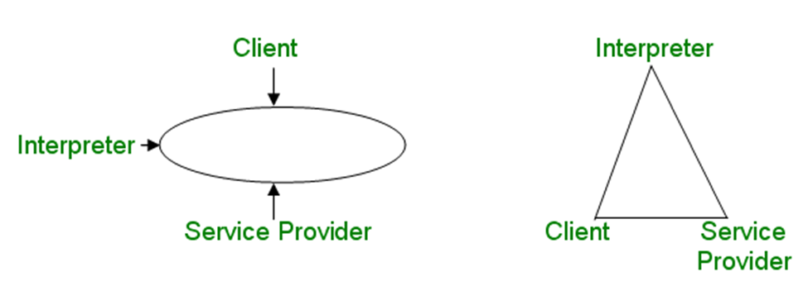
You will interpret consecutively (not concurrently). Information will be conveyed to you in chunks and this will give you opportunity to convey the message to the client.
What’s the difference between translating and interpreting?
Translator: Interprets written text
Interpreter: Translates orally
In Admission, Review, Dismissal (ARD) meetings and Assessments, we use interpreters. When we need forms translated into another language, we use translators.

Sample: Mandarin Narrative Sample – Story Retell & Translation

Finding the frog | 在找青蛙
The frog is in the bucket. | 青蛙在桶子裡面
The dog is on the bed. The dog is on the bed. | 小狗在床上 小狗在床上
The dog hides inside of the bucket. | 小狗躲在桶子裡面了
The dog is playing. | 小狗在玩
The dog falls off, falls down. The dog falls down. | 小狗掉下來了 摔跤，小狗摔跤
Here are the bees. | 這有蜜蜂
The dog is playing with bees. | 小狗在玩蜜蜂
The child is playing. | 小朋友在玩
That is an owl. And bees. | 那個是貓頭鷹 和蜜蜂
The dog runs away the bees. | 狗把蜜蜂跑走
Owl | 貓頭鷹
The child is looking for the frog. Owl | 小朋友在找青蛙 貓頭鷹
The deer is coming. | 鹿來了
The deer and the dog, falls off. | 鹿和小狗 摔跤了
The deer, the boy and the dog falls off. | 鹿 男孩和小狗摔跤了
Falls into the pond. Falls down into the pound. | 摔在池子 掉在池塘裡面了
The dog is coming the boy. | 狗狗來了男孩
The boy is finding the frog in the wood. | 男孩在木頭裡面找青蛙
The dog finds the frog. | 狗狗找到青蛙
I am finished. | 我結束了

